345 Lab 9

1. No, we were not able to capture 802.11 packets because, by default the network adapter filters and translates unwanted packets.
2. 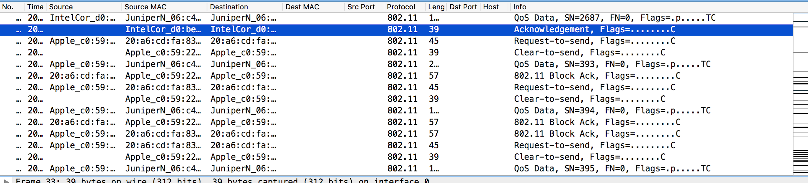
   1. Yes beacon broadcast were found from the AP.
   2. No nonce or key installation messages were not captured because our NICs were set to monitoring mode and thus could not see the last part of the 4-Way handshake.
   3. The two AP SSID broadcasting the most Beacon frames in this capture were: 30 Munroe St, and Linksys12
   4. Source MAC: 00:13:02:d1:b6:4f

AP MAC: 00:16:b6:f7:1d:51

First hop MAC: 00:16:b6:f4:eb:a8

Source IP: 192.168.1.109

Destination IP: 128.119.245.12

Destination IP corresponds to the AP because the AP MAC address matches previous communication with that IP.

* 1. There is a DHCP release, and a Deauthentication corresponding with the 30 Monroe St Access point. We expected a Disassociation frame but did not find any associated with that Access point.

